Composite Interlocking Deck Tiles Installation Guide
- Calculate the area of your project and double check the order amount:
  - Length x Width = Area (in²)
  - Area(in²) /136.59375 (in²) = Number of Tiles
Note: Individual tiles are 12.2”x12.2” squares but the Exposed surface of each tile is ~ 11.875” x 11.875”
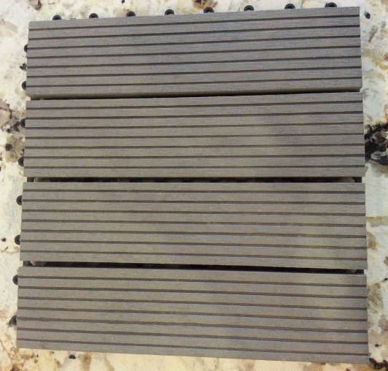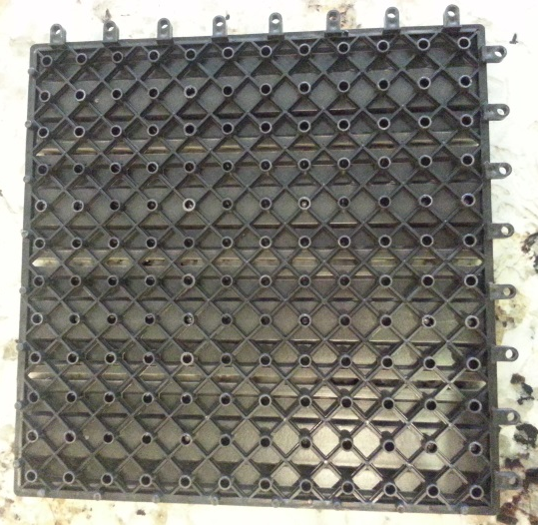
Groove
Tongue
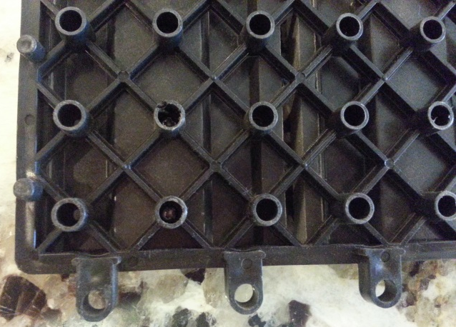
Installation: Click Tiles together in the patern of your choice. ( Note: to keep lines straight, Start in a corner or in the center of the longest wall and work outwards)
Trimming Tiles to size: Mark the size along the bottom mat, (avoiding the screws) cut the tile to size using a hand saw.

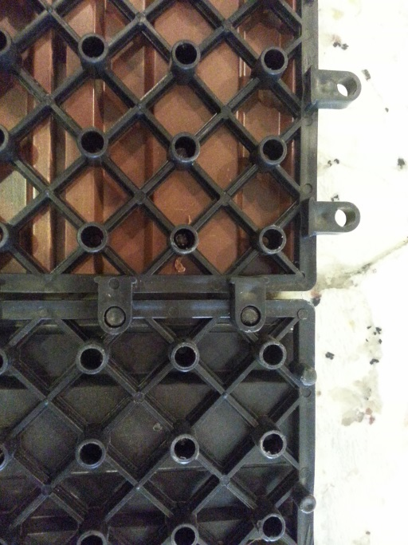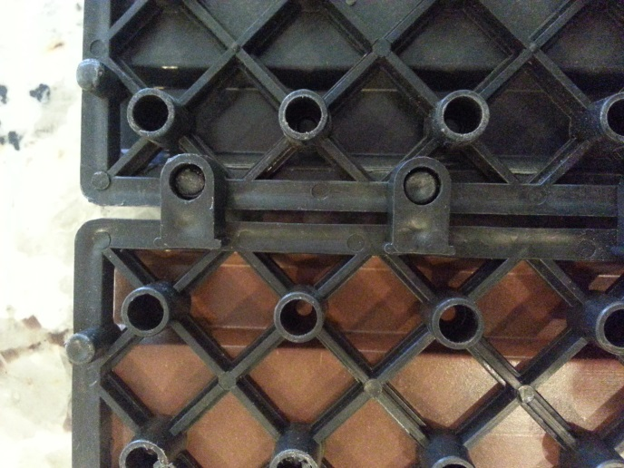
Opposing Pattern Long Pattern
- The distance of at least 1 inch from walls or other obstacles for a 16” long installation to allow for expansion of the interlocking composite DIY tiles is necessary at installation

